Task1

General Data:

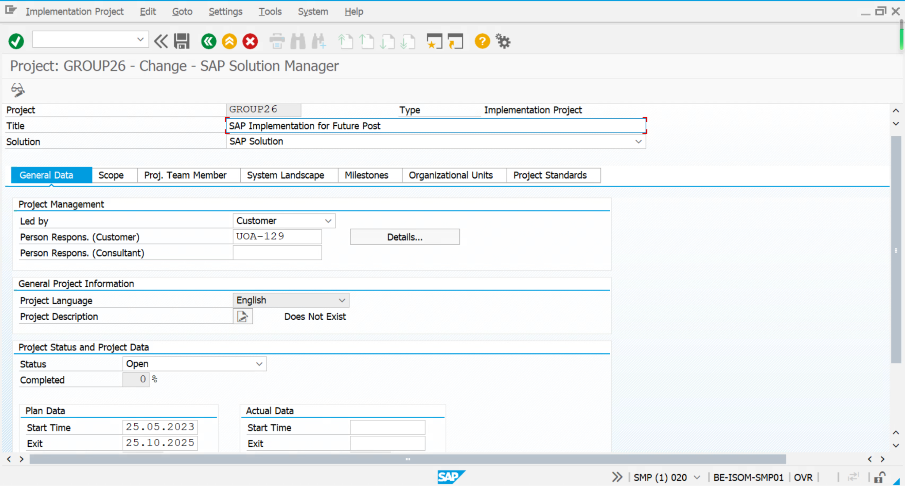

Roadmap:

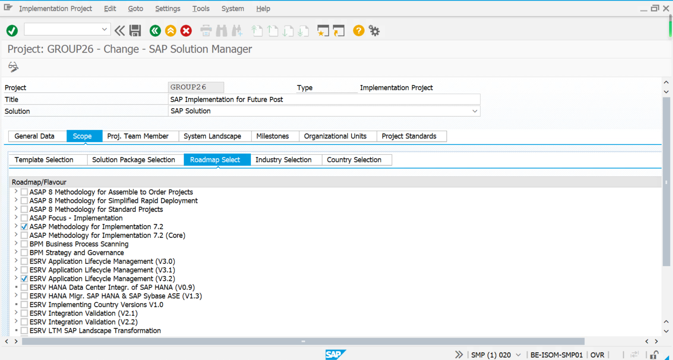

Industry:

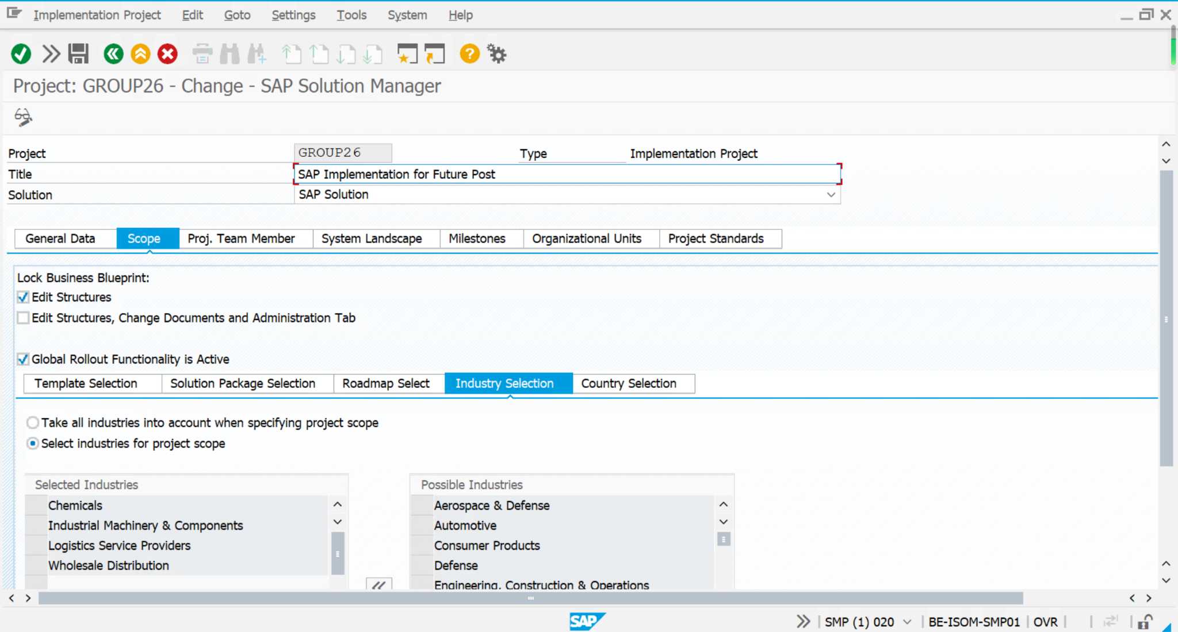

Country:

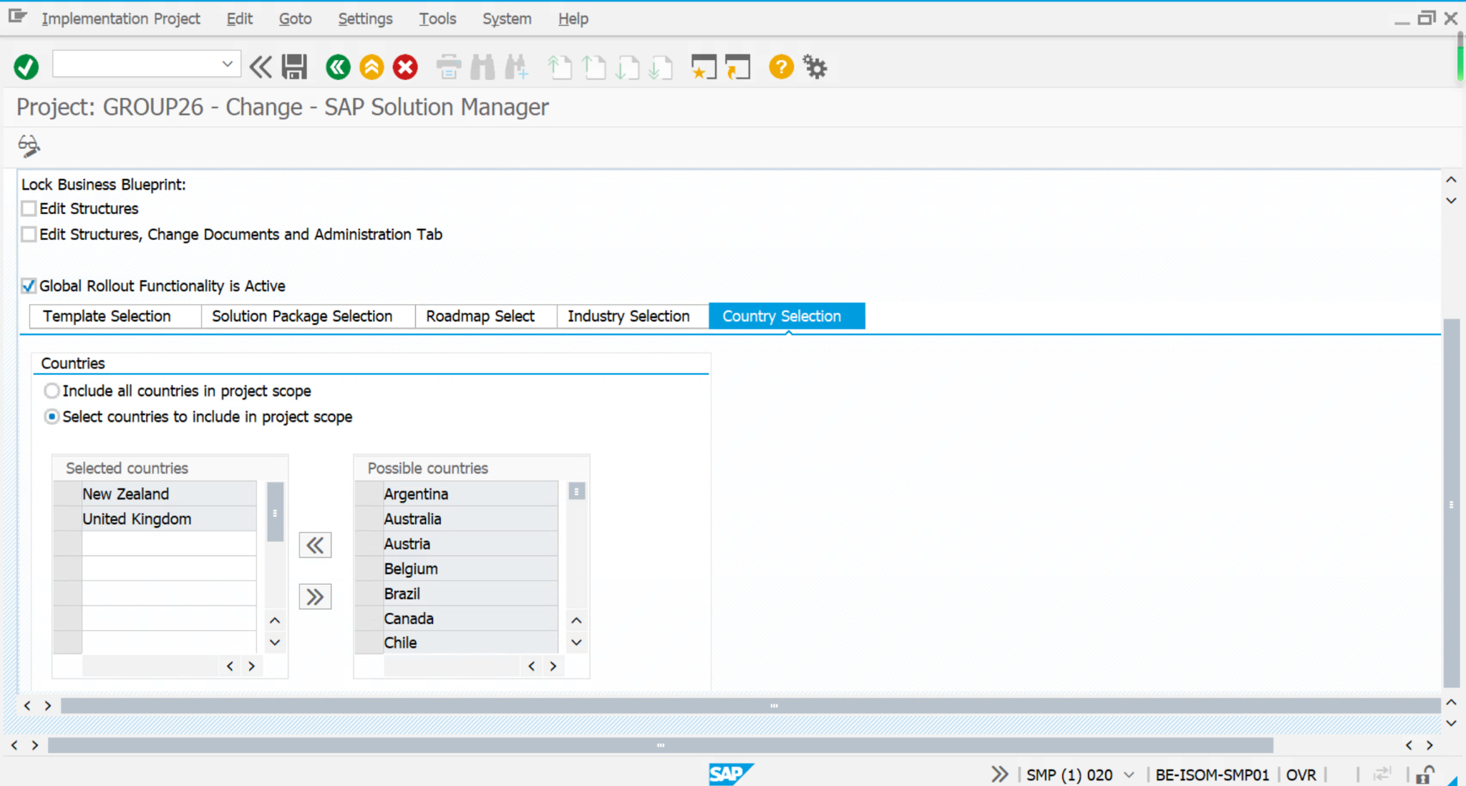

Project Team:

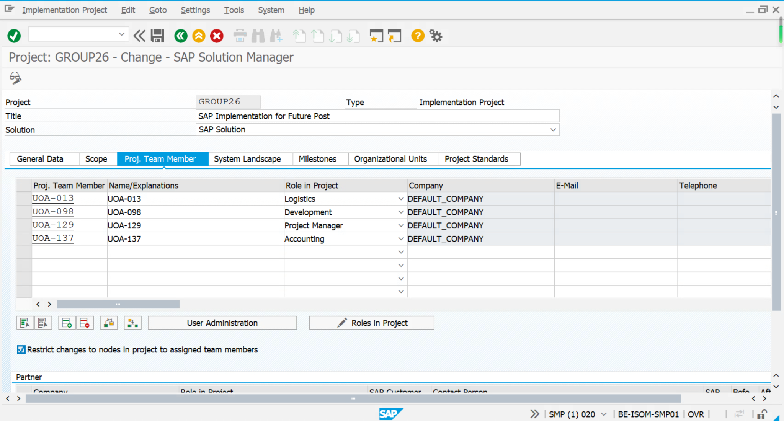

System Landscape:

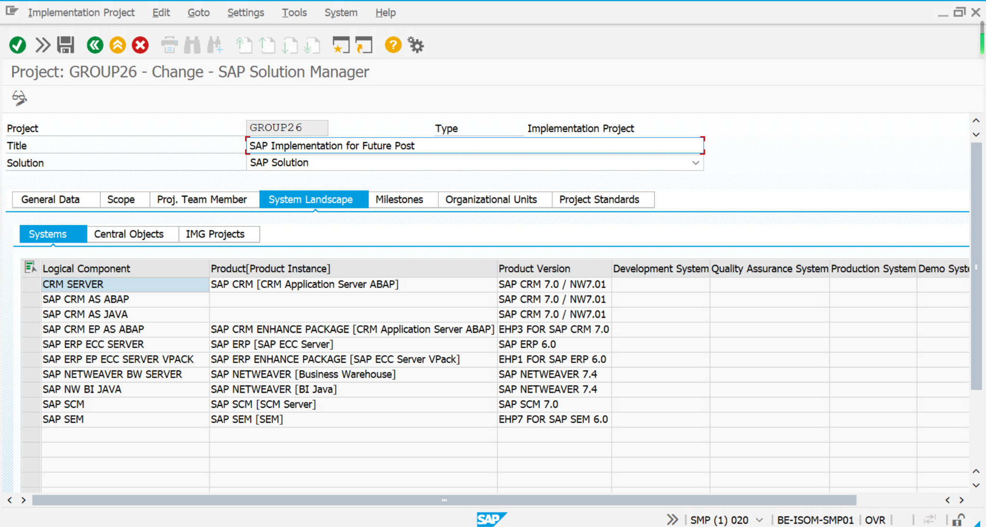

Task2

a:

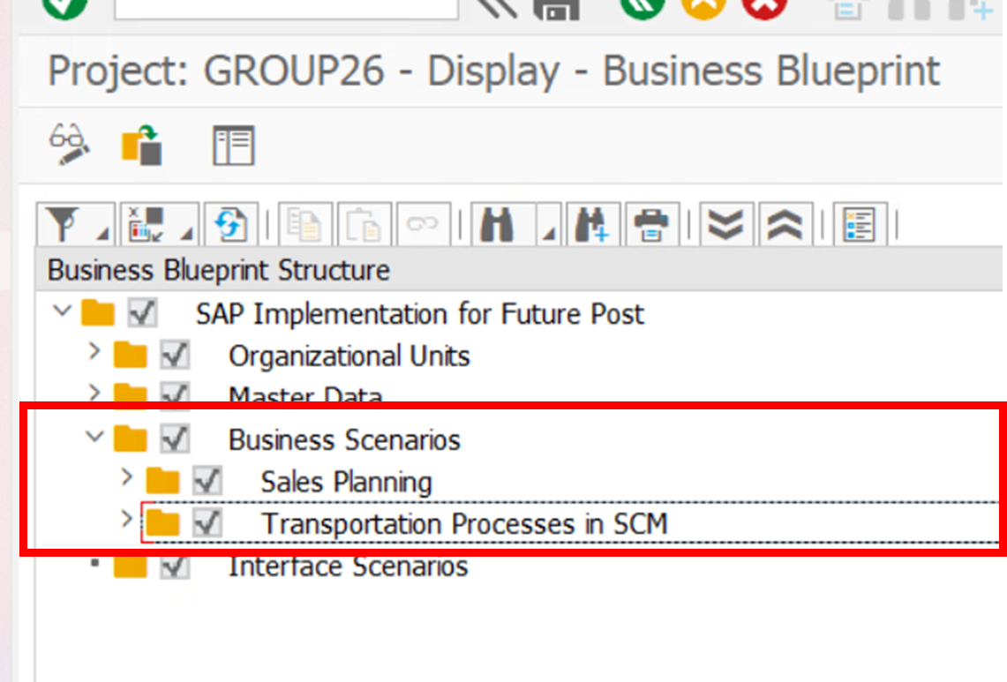

* **Business Scenarios #1: Sales Planning**

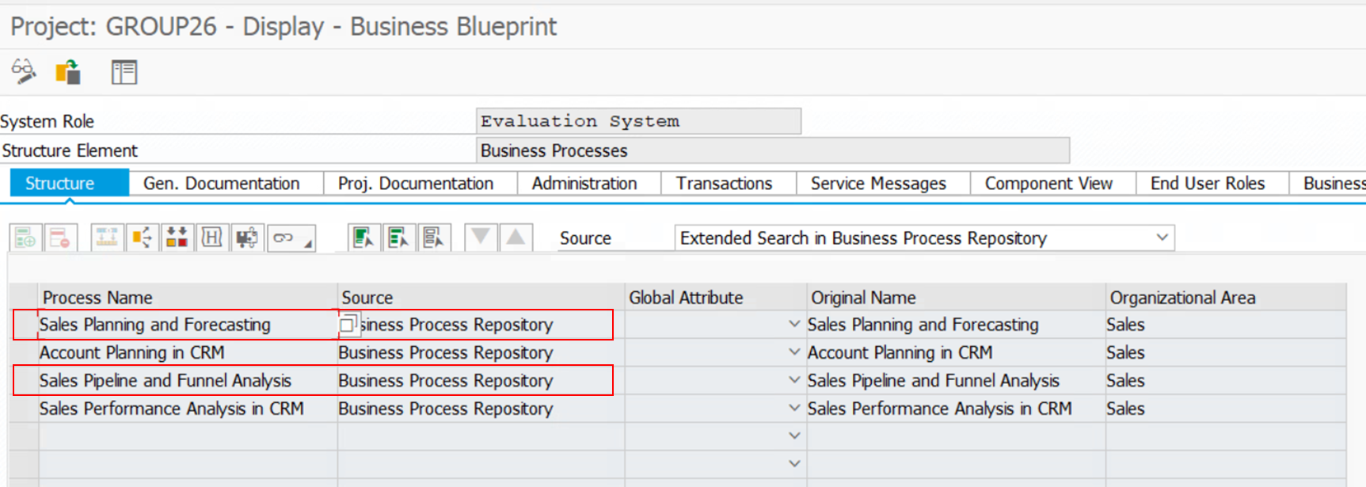

* + Sales Planning and Forecasting

As Future Post currently experiences expansion and globalization, they need to be well prepared for the sales planning and demand forecasting, which lower the risk of raw materials waste and reduce the potential excessive production costs. Future Post should be required to make a precise and detailed plan before they are going to build a second factory in Blenheim that’s located in the UK. They need to fully consider market segments in that country and then develop a model to establish a sales prediction. Once the model is validated, the factory can produce the required volume of production. Overall, Sales Planning and Forecasting is necessary across the whole business development stages.

* + Sales Pipeline and Funnel Analysis

Sales Pipeline and Funnel Analysis is a specific tool linked to the high value process of Future Post called ‘Lead to Cash’. This implementation provides best business practices as to refer in the sales planning scenarios. This particular intuitive model specifies solutions that help Future Post to streamline the process of the prospect from inception to sale, which include potential buyers track part, quotation part, etc. Future Post can benefit from the Sales Pipeline and Funnel Analysis to increase sales chances and orders from customers.

* **Business Scenarios #2: Transportation Processes in SCM**

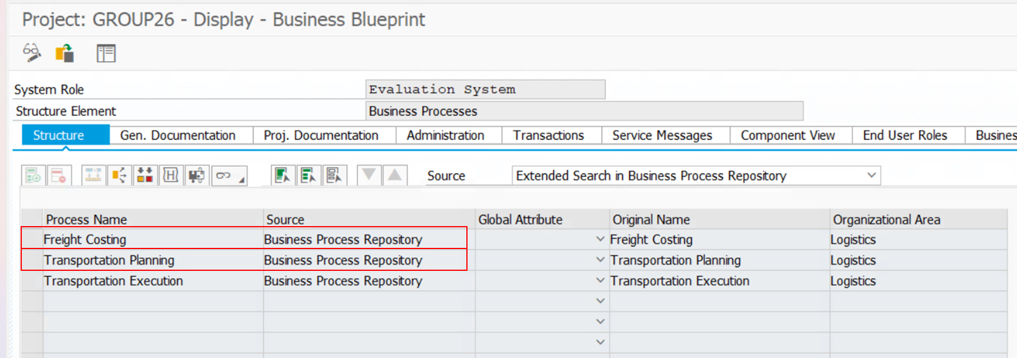

* + Freight Costing

Freight cost is an essential factor to consider when Future Post creates export business and further expands their company in a worldwide market. For example, they need to choose the suitable carrier companies through their own reasonable freight tendering process. Freight Costing provides solutions to streamline this process. What’s more, companies need to control the freight costs within a reasonable range to control the total costs.

* + Transportation Planning

Transportation Planning information system in the supply chain management provides functions to support Future Post to optimize their transportation process while minimizing cost and maximizing efficiencies. For instance, the implementation of this system would be able to address delivery delays or provide solutions to handle disruptions somewhere in the supply chain under the export module of Future Post.

b:

One of our chosen business scenarios for Future Post: Sales Planning

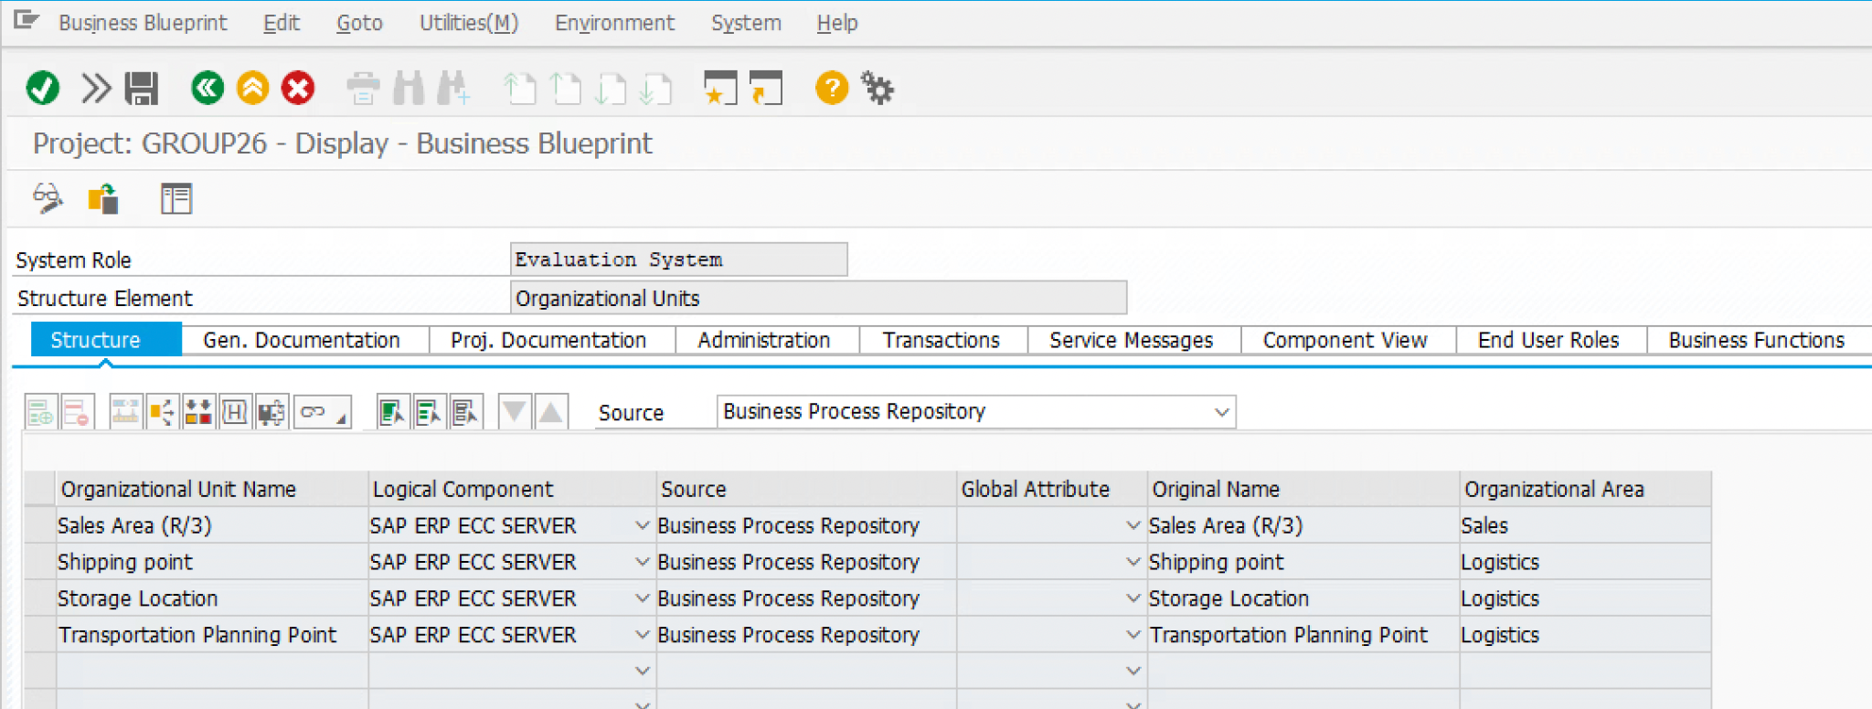

**Organizational units** that are related to the Sales Planning:

* Sales Area

A sales area consists of three components which include:

1. Sales Organization: Give a definition to the sales strategy and tasks for a particular product within a company.
2. Distribution Channel: Represents a variety of ways that the company can use to reach out its customers.
3. Divisions: Allows companies differentiate their products into categories such as product type, market segmentation or geographic location.

As Future Post intends to expand overseas (e.g., build a second factory in Blenheim) by implementing the sales planning, it is necessary to combine these three components of the sales area, which will help the company to define its own set of customers and materials for New Zealand and the UK respectively.

* Storage Location

This is where companies’ stock is physically stored within a plant. One of the characteristics of the storage location is the inventory management function. It can help Future Post track the stock level and the flow of materials, lowering the risk of wasting materials and excessive production costs. Additionally, it will update the latest storage location when receiving or delivering the goods. In this case, it is linked closely with the goals of the sales planning.

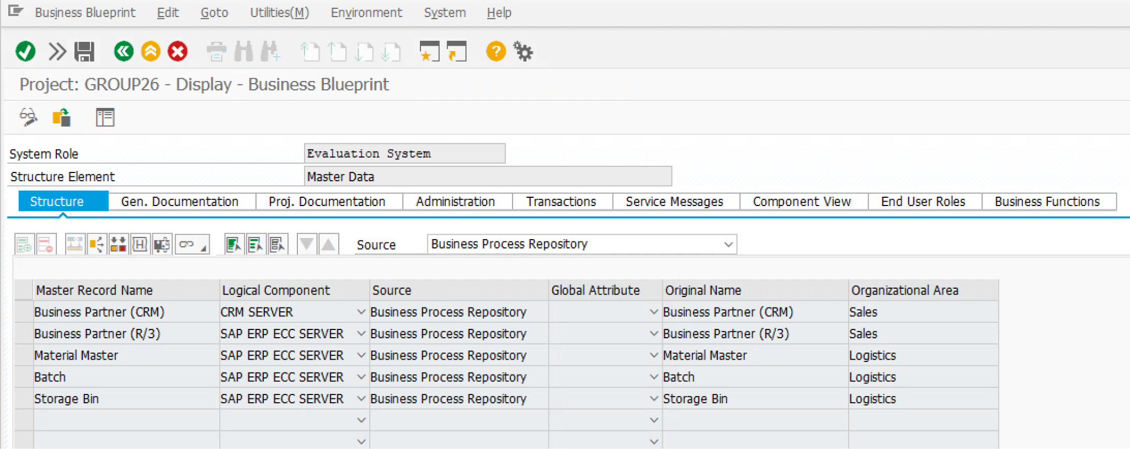

**Master data** that is related to the Sales Planning:

* Material Master

This is the computer system’s unique identification code for a material that can be utilized throughout the organization. SAP stores all records relating to design, sales, distribution, purchasing, planning, and production within the material master data. The master data is linked to one of Future Post’s High-Value Business Processes, which is called ‘Lead to Cash,’ includes: Discover sales leads; Nurture the leads; Convert the leads into orders; Manage order remittance. In this case, the material master allows Future Post to trace all the records of the Lead to Cash process and the Sales Pipeline and Funnel Analysis used in the Sales Planning.

c:

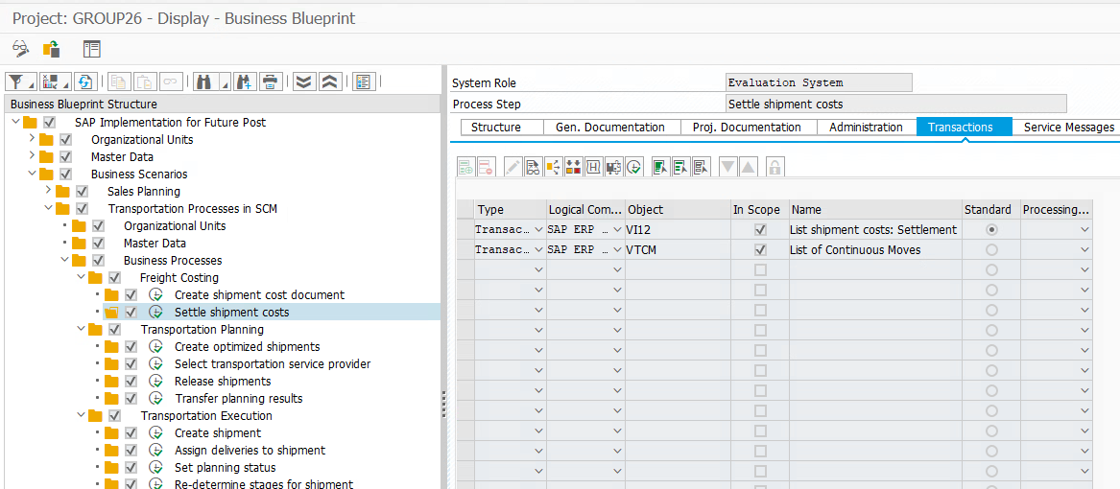

* The transaction code VI12 in SAP is used to list shipment costs that have been settled. It can be included in the list of transactions to support the "Freight Costing" business process for settling shipment costs.
* The transaction code VTCM in SAP is used to manage continuous moves, optimizing transportation costs and reducing transit times for multiple shipments. Also relevant for “Freight Costing”.

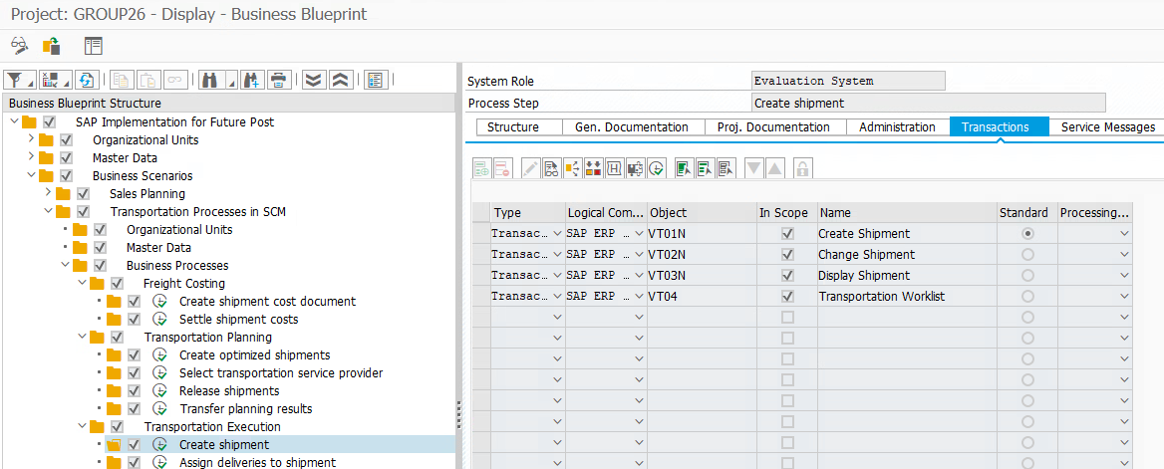

* VT01N (Create Shipment): this transaction is used to create a shipment document in SAP and is relevant for the "Transportation Planning" process.

By using VT01N, users can create a new shipment document and enter all the required information such as the shipping point, delivery destination, transportation mode, and other details.

* VT02N (Change Shipment): modifies an existing shipment document in SAP, relevant for "Transportation Planning".

By using VT02N, users can change the information related to a shipment document such as the shipping point, delivery destination, transportation mode, and other details.

* VT03N (Display Shipment): displays an existing shipment document in SAP, relevant for "Transportation Planning".

By using VT03N, users can view all the information related to a shipment document such as the shipping point, delivery destination, transportation mode, and other details.

* VT04 (Transportation Worklist): displays a list of shipments ready for transportation in SAP, relevant for "Transportation Execution".

By using VT04, users can view all the shipments that are ready for transportation and take appropriate actions such as assigning carriers and scheduling deliveries.

Task3

a:

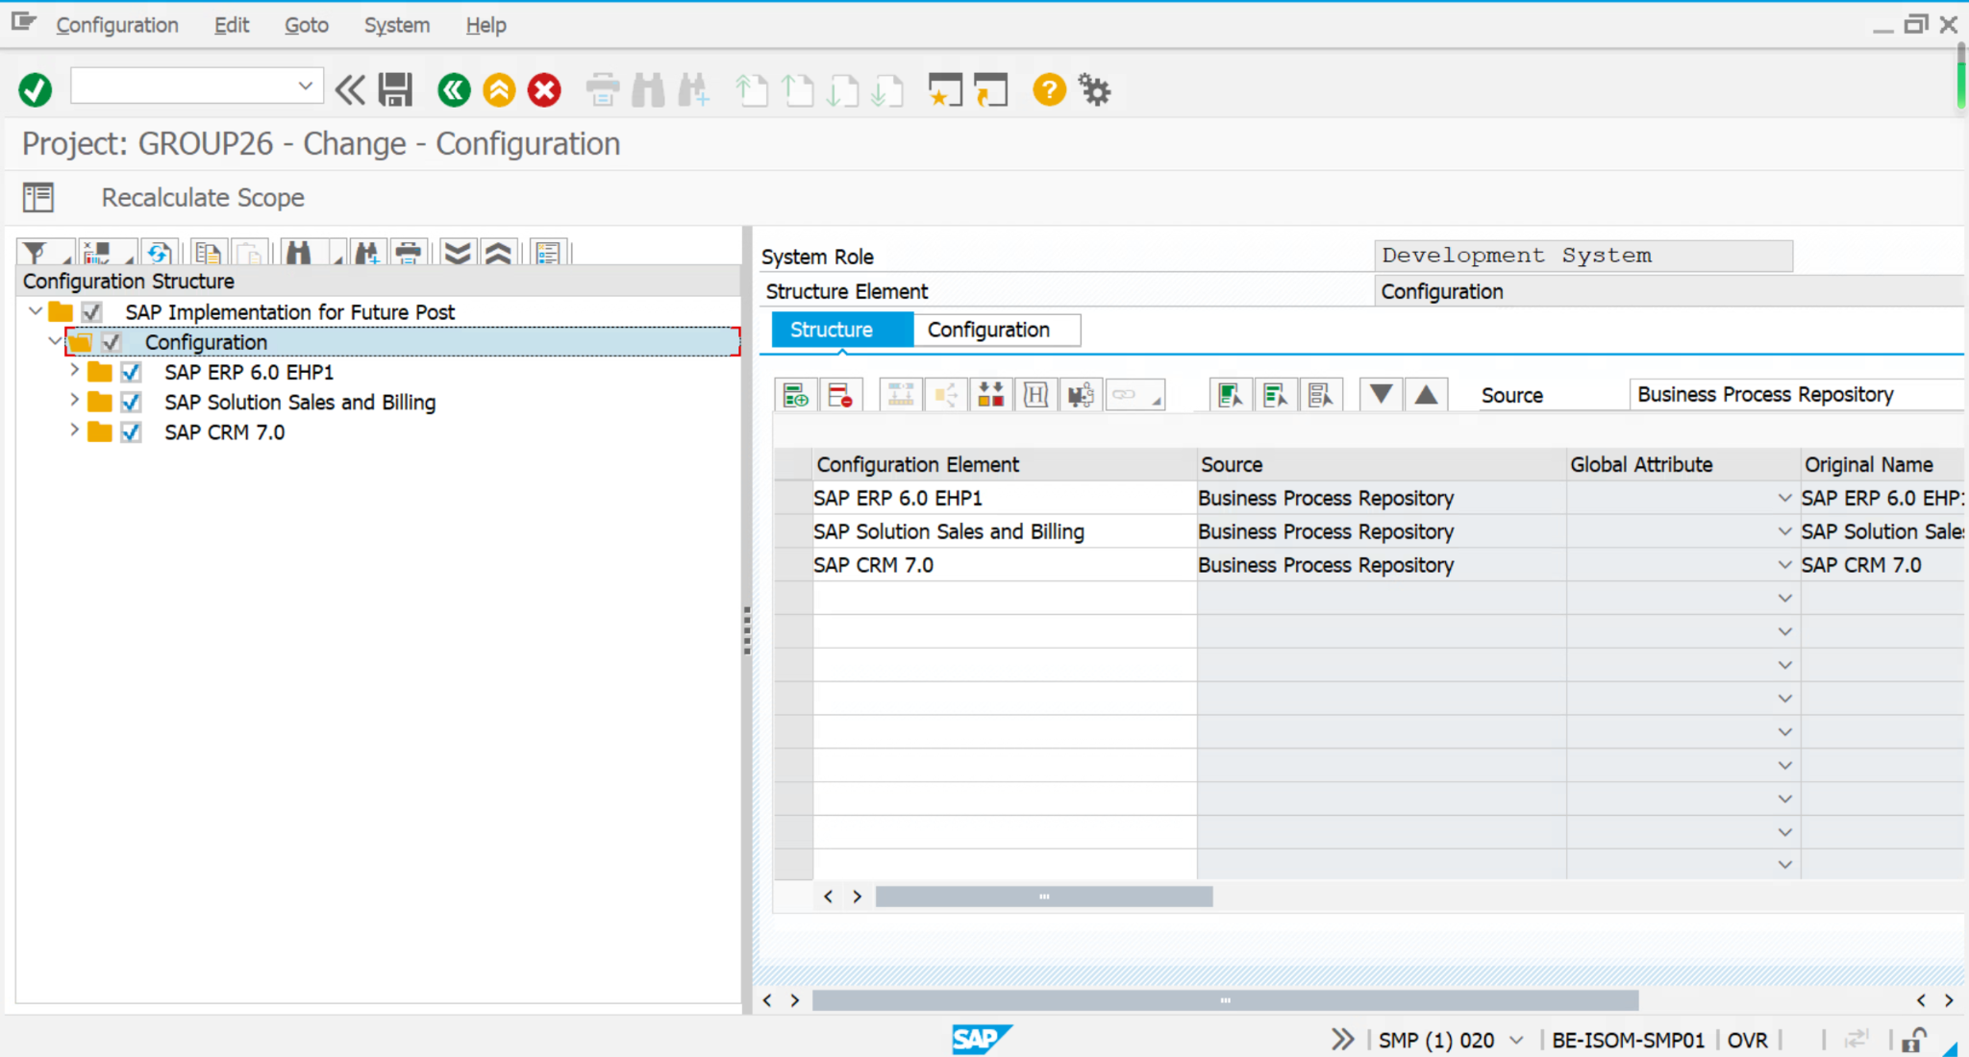

b:

1. Solution Billing: Basic Configuration

Path: Configuration->SAP Solution Sales and Billing->Solution Billing: Basic Configuration

1. Communication Settings

Path: SAP CRM 7.0->Basic settings for SAP CRM->Communication Settings

1. Data Replication

Path: Configuration->SAP CRM 7.0->Basic settings for SAP CRM->Data Replication

1. Product Configuration

Path: Configuration->SAP CRM 7.0->Basic settings for SAP CRM->Product Configuration

1. Business Package for SAP CRM

Path: Configuration->SAP CRM 7.0->Basic settings for SAP CRM->Business Package for SAP CRM

1. Use Easy Enhancement Workbench for Marketing

Path: Configuration->SAP CRM 7.0->Basic settings for Marketing->Use Easy Enhancement Workbench for Marketing

1. [Utilities]: Set Up IS-U Marketing Integration

Path: Configuration->SAP CRM 7.0->Basic settings for Marketing->[Utilities]: Set Up IS-U Marketing Integration

1. Set Up Organizational Units

Path: Configuration->SAP CRM 7.0->Basic settings for Service->Set Up Organizational Units

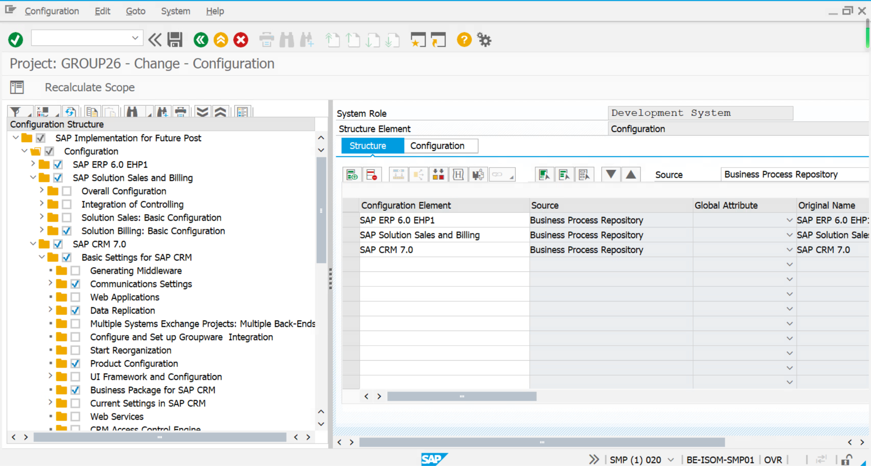

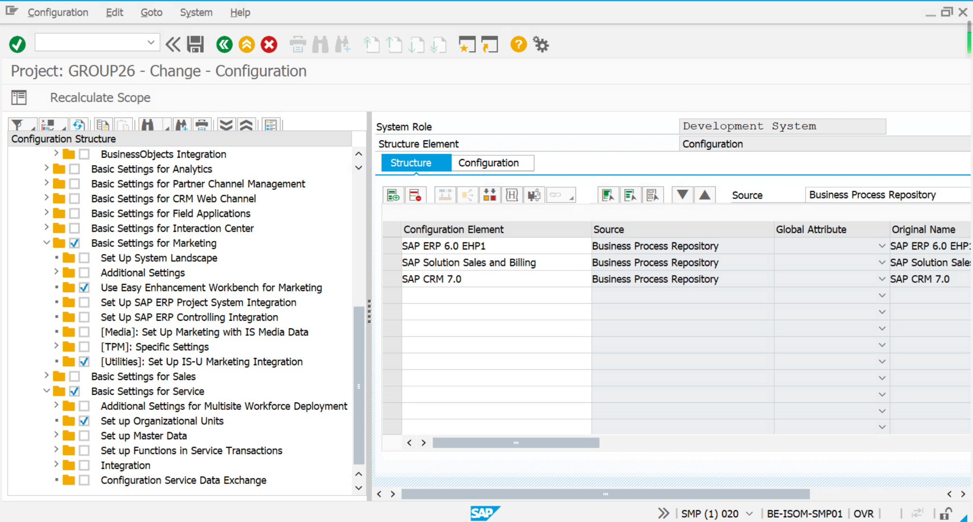

c:

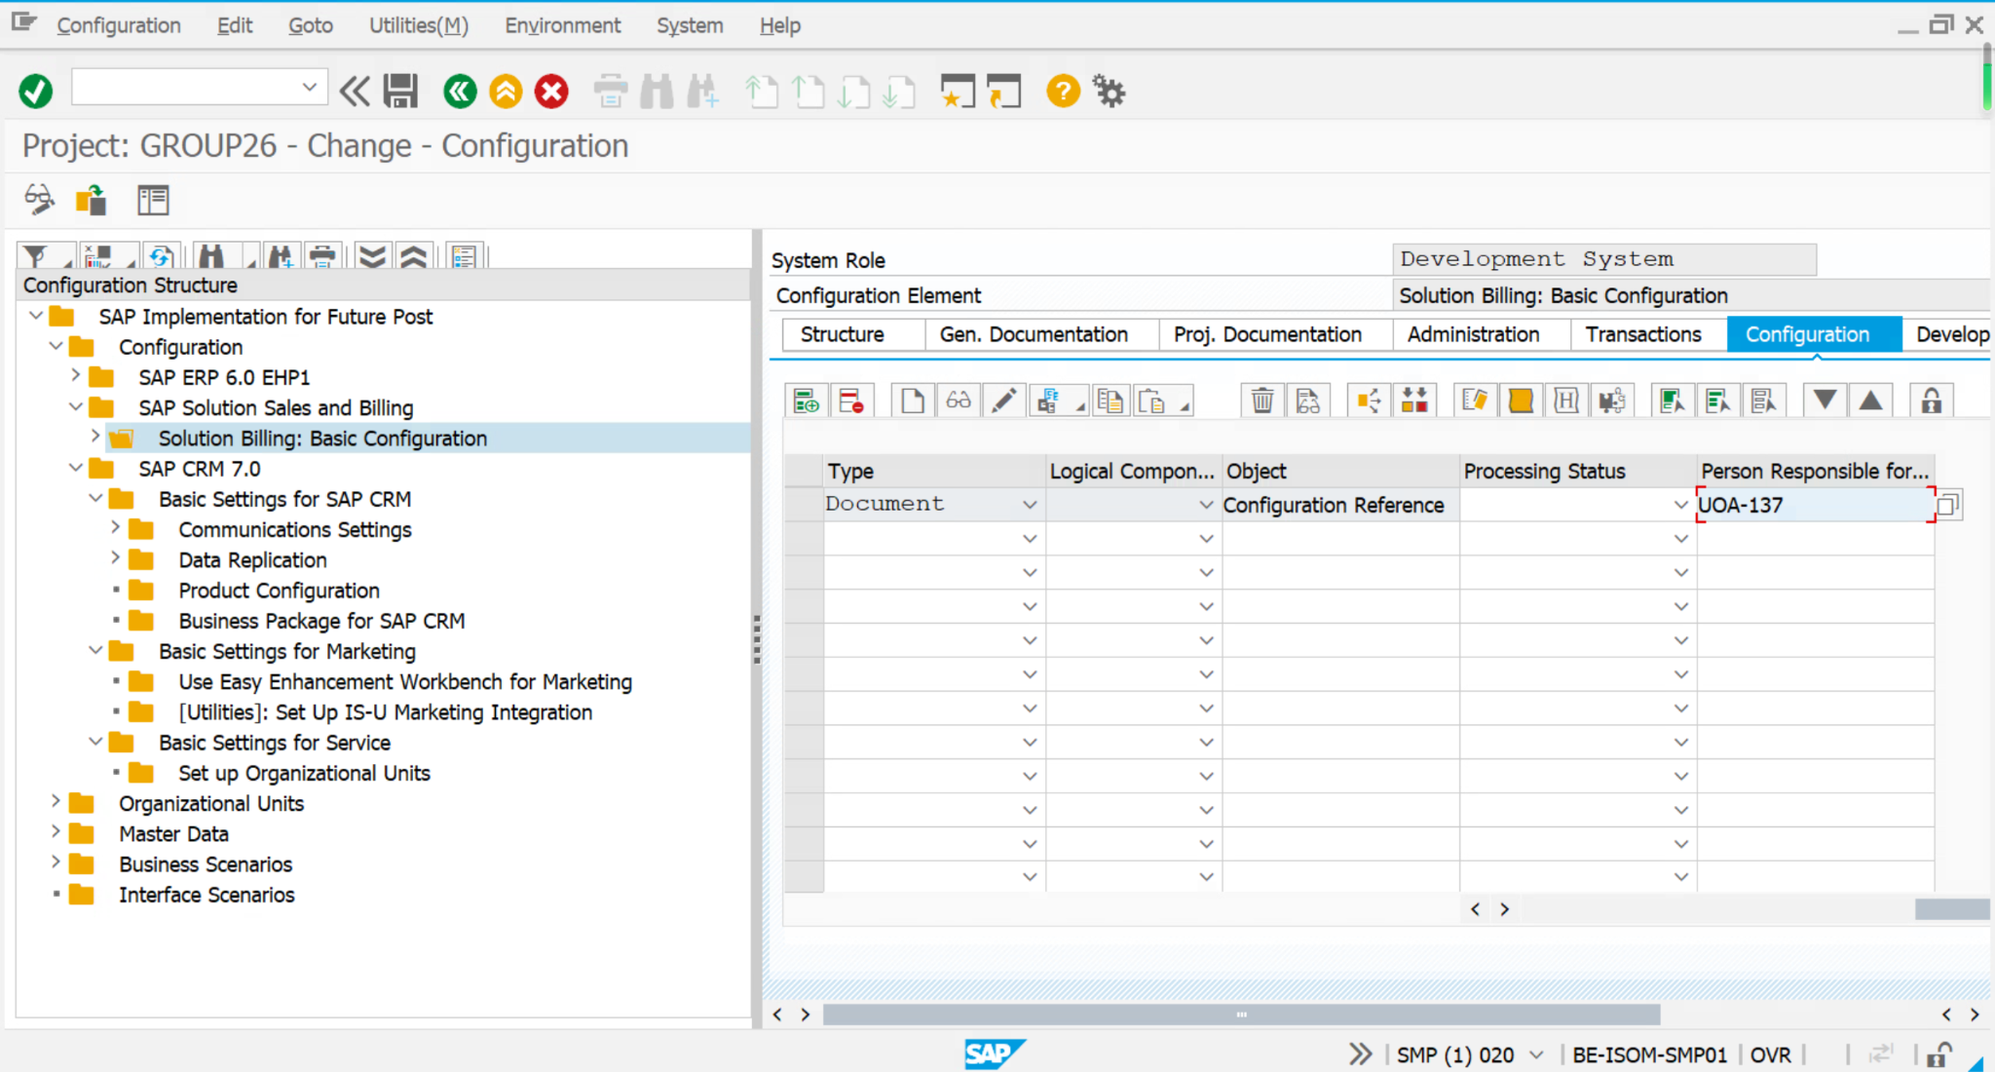

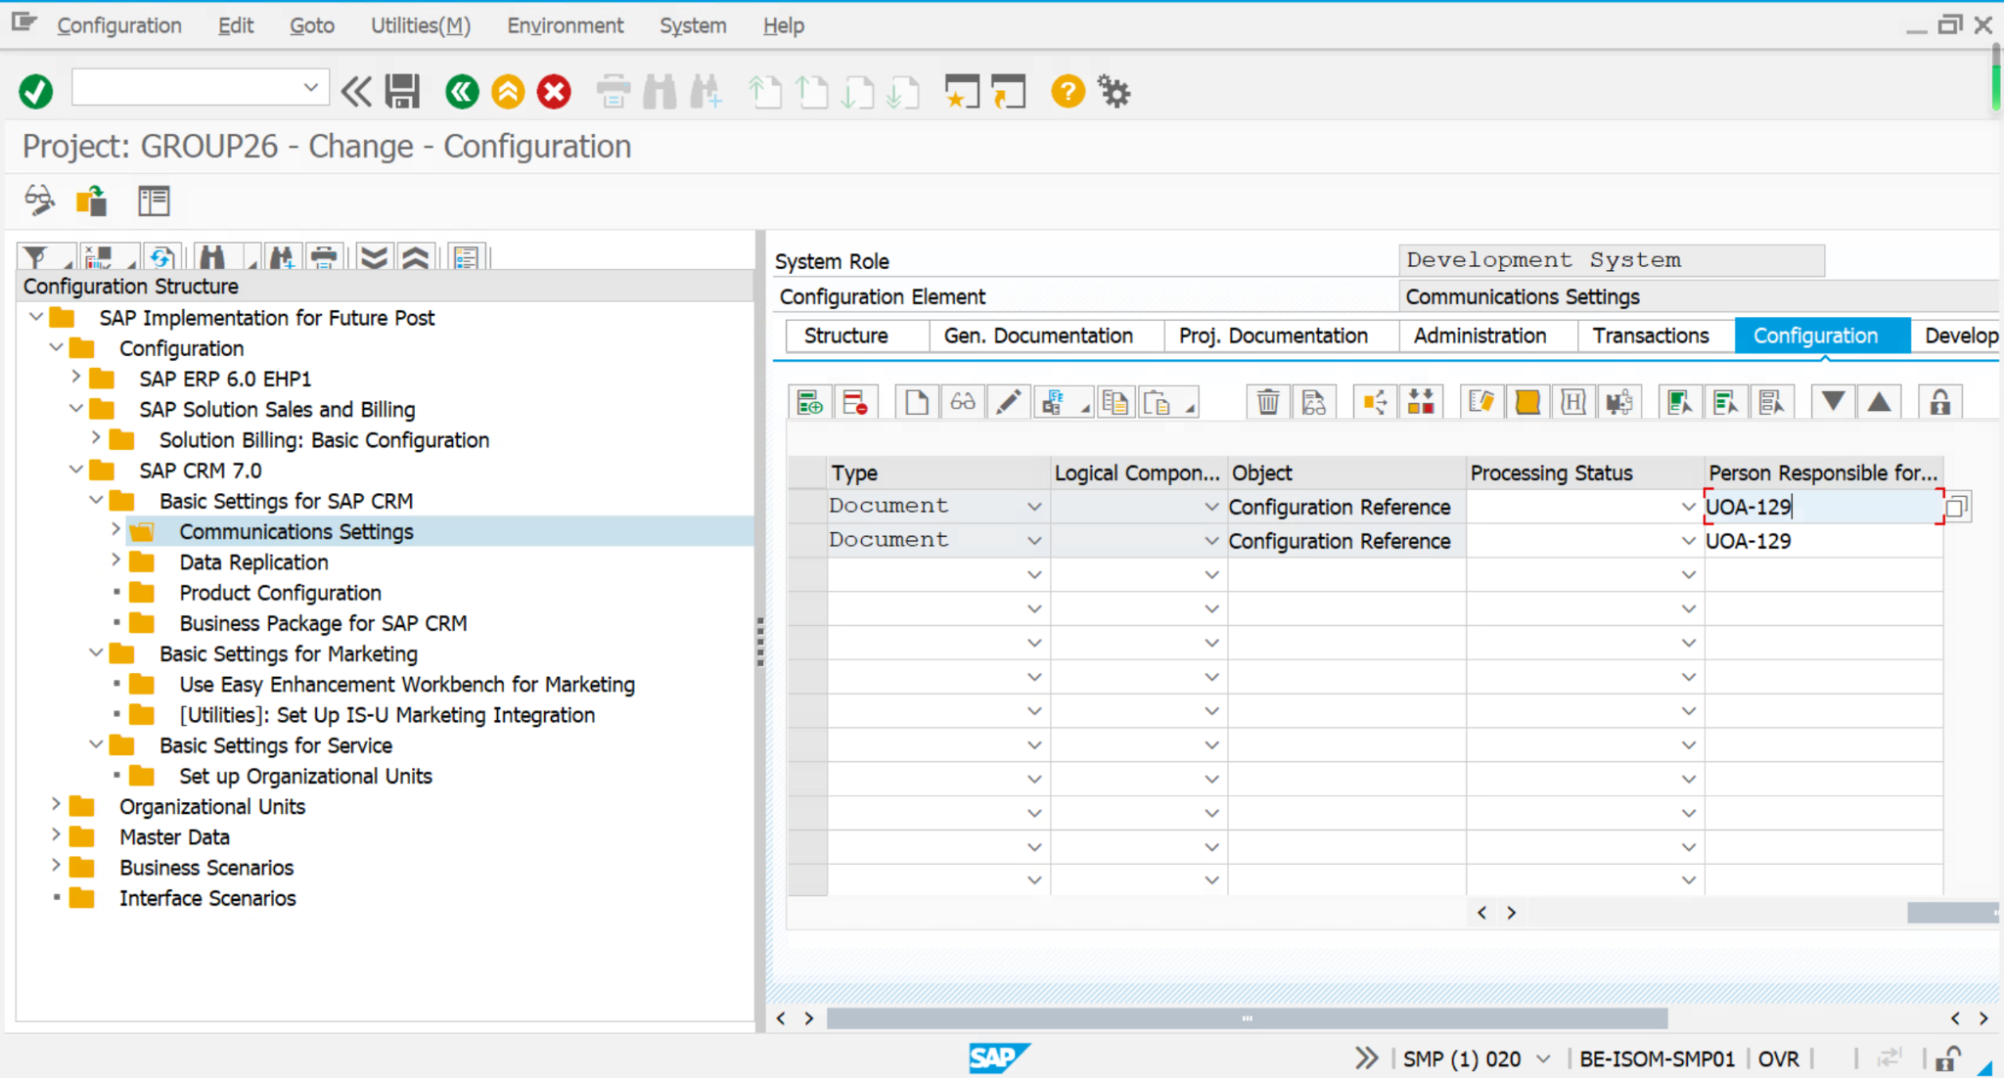

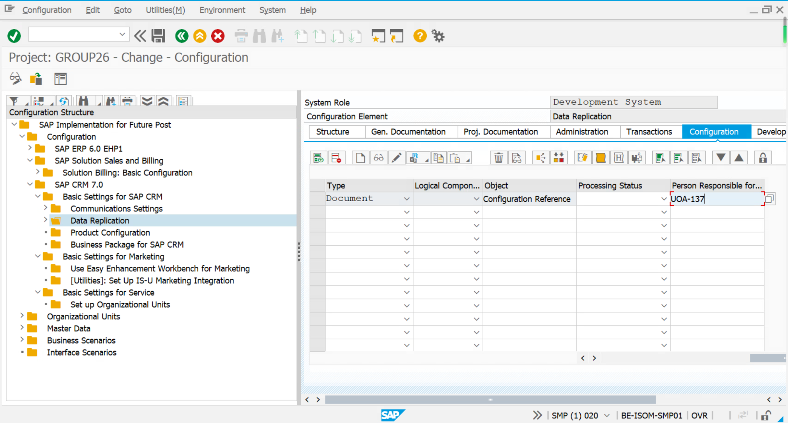

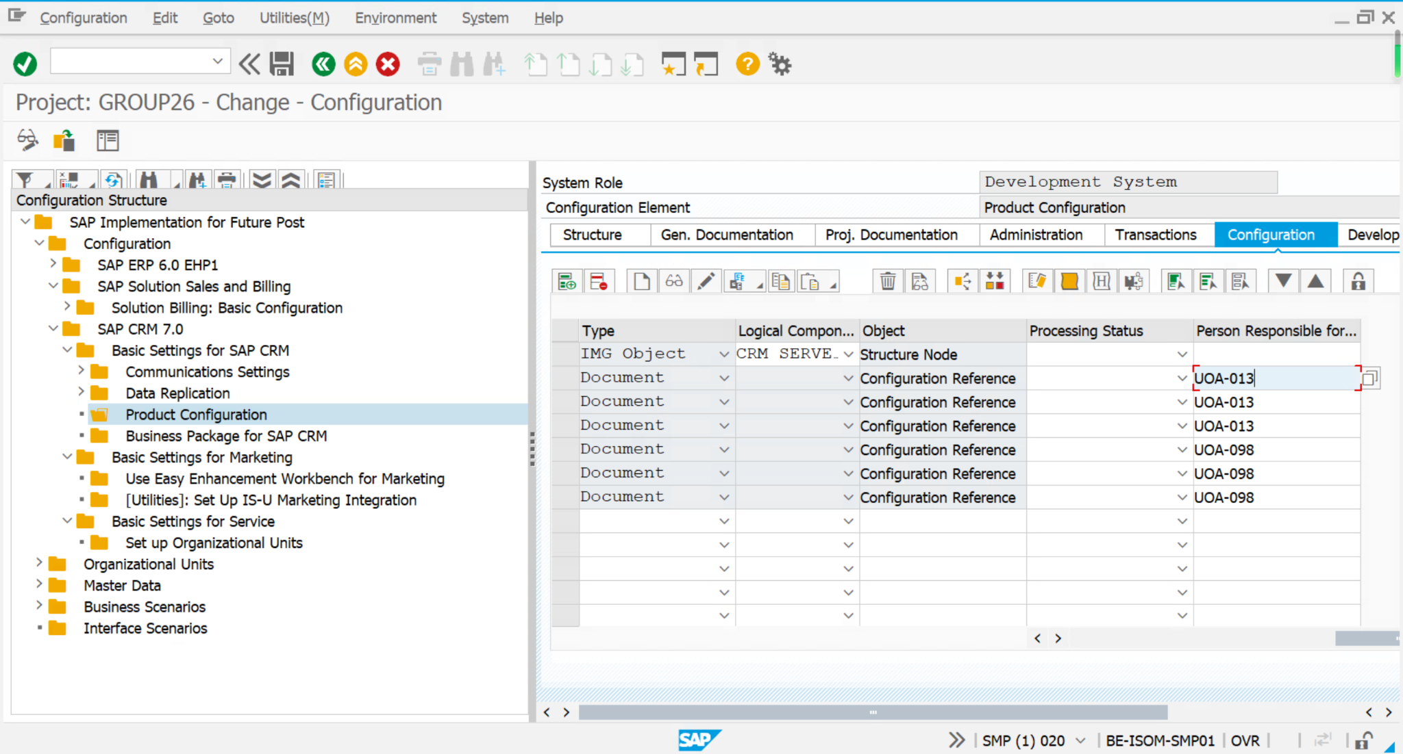

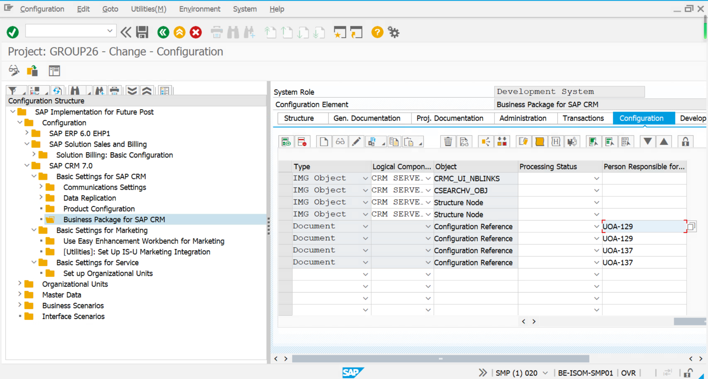

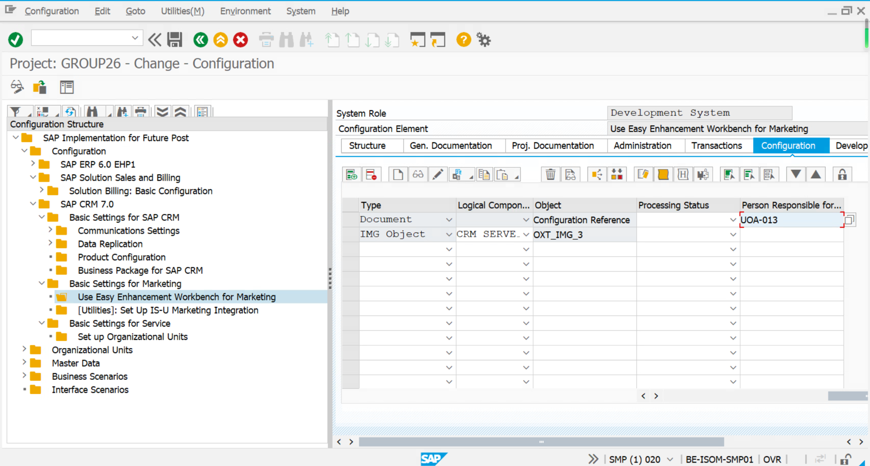

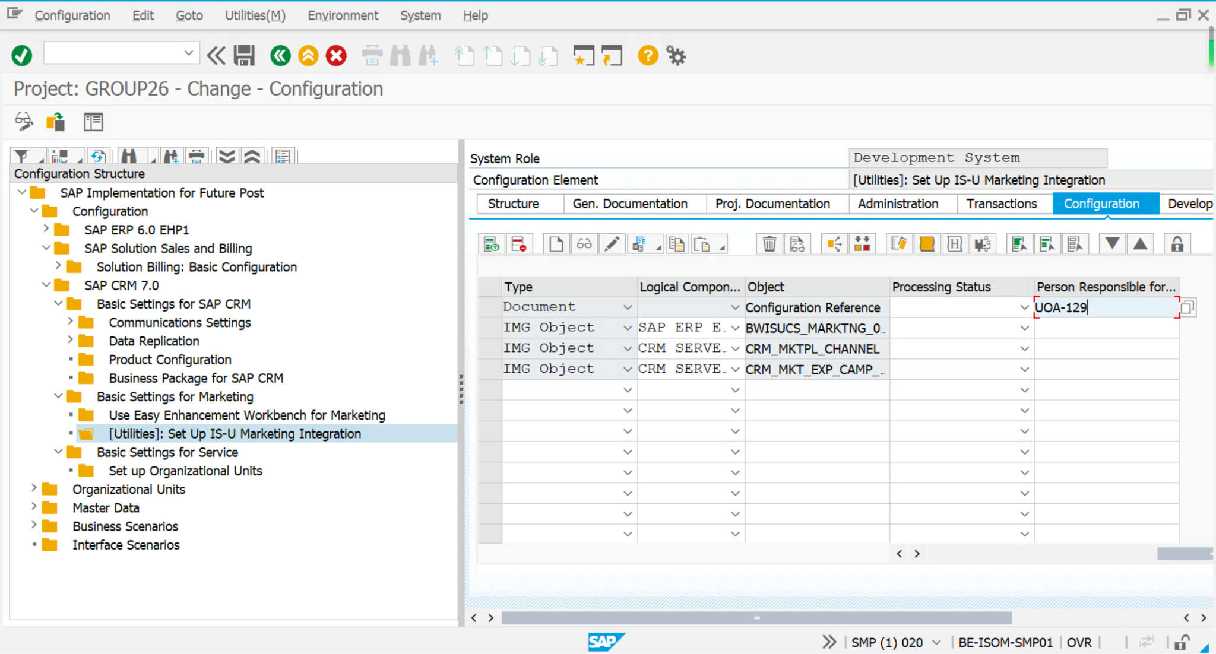

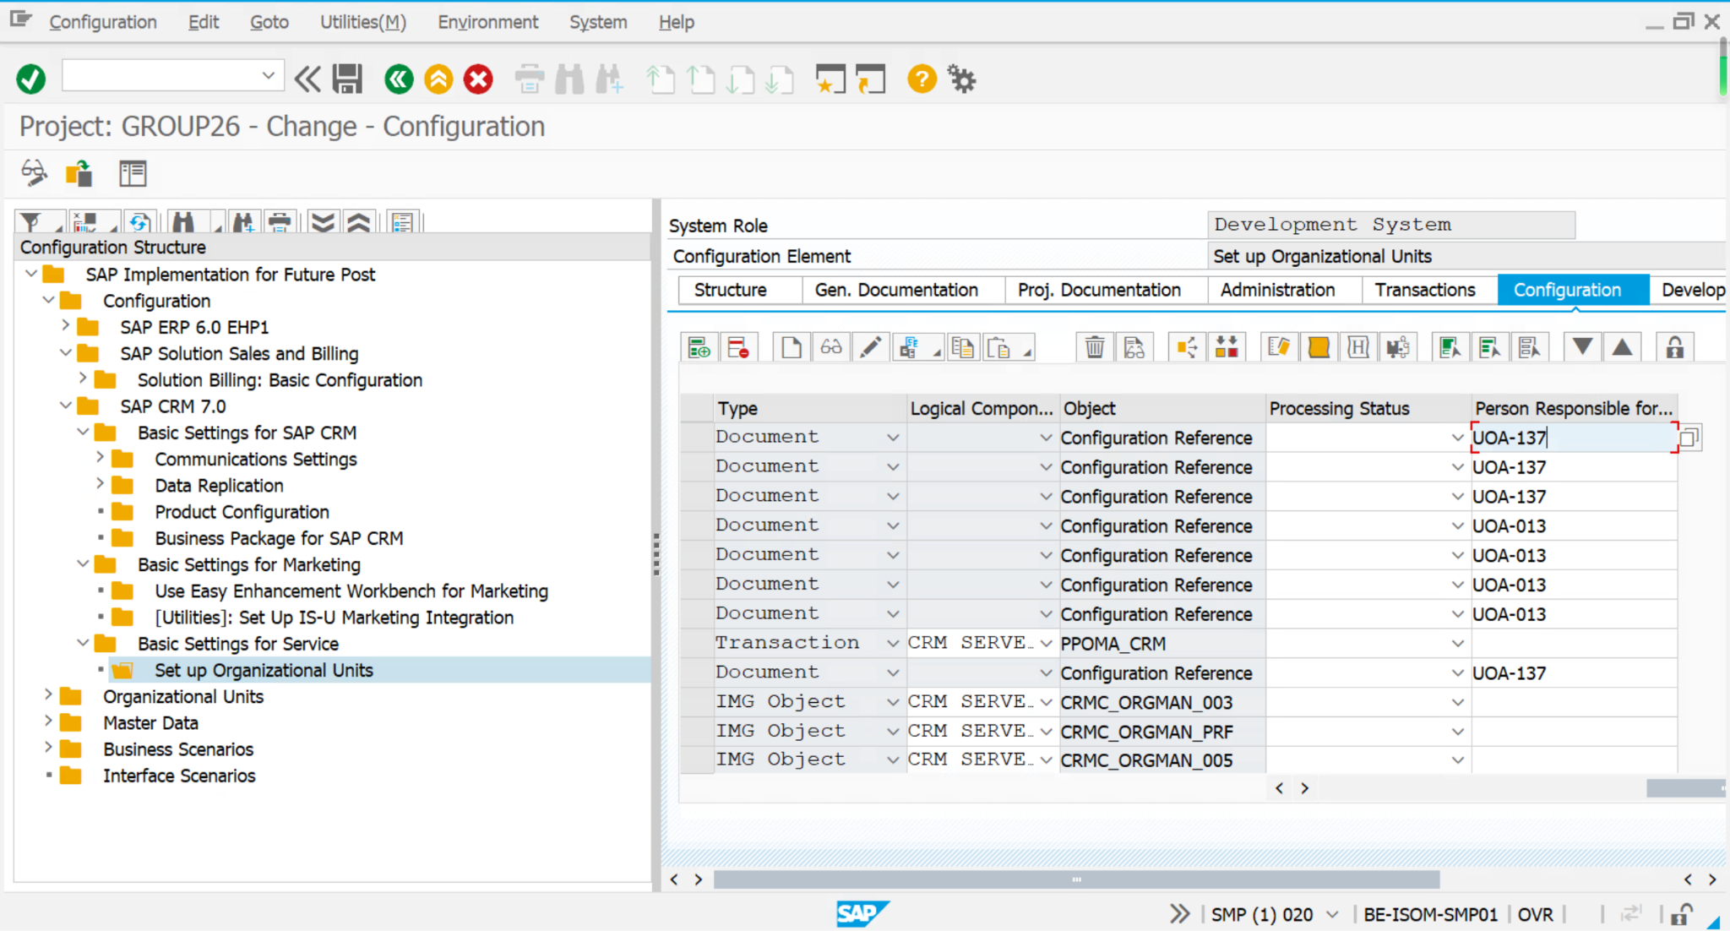

d:

